

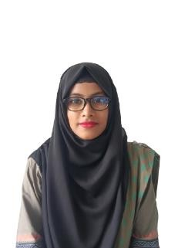
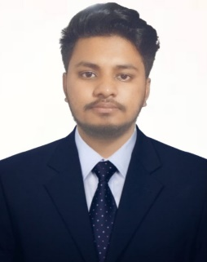
Raihanul
Islam
+8801623784806
(whats app & telegram) officeraihanul@gmail.com
Shasongacha,Cumilla
male
17 December, 2003 Bangladeshi
Single
Computer Modern Office
Management
Computer Basic & ICT Application
Spoken English in SmarIT Phitron (C,C++)
web development in bongo dev

PROFILE
Mst.Sajeda
Akter

+8801894744127
(whats app & telegram) officesajeda522@gmail.com
Shasongacha,Cumilla Female
18 december, 2003
Bangladeshi
Single

Computer Modern Office Management
Computer Basic & ICT Application
Spoken English in SmarIT Phitron (C,C++)
web development in bongo dev

Assala-Mu-Alaikum, This is Raihanul Islam. I love to explore and learn new things. I am a quick and self-learner. I can follow a leader, and at the same time, I can run in the front leading the team. I am an ambivert person. I love to think positively and try to motivate others as well. Whenever I do anything, I try to do it with perfection.

EDUCATION

CCN University of Science &Technology , Cumilla
Bachelor’s in Computer Science and Engineering
last semCGPA 3.50
2025-Present

Comilla Residential College,Cumilla

Higher Secondary Certificate
Science
GPA 4.50
2021
IBN Taimiya school and College,Cumilla

Secondary School Certificate
Science
GPA 4.83
2019




SKILLS
Microsoft Word
Microsoft
Microsoft Excel
Communication
Well Observation
Bangla
Hindi
INTERESTS

Travelling Singing Playing
Swimming

ORGANIZATIONS
Organization

- Admin – Verto Fashion
- Admin-Maan fashion
- Admin-Pakghor

